GRADING TABLES: what are they all about?
Starting Point
The Egracons project wants to adhere as closely as possible to the (general) instructions on how to prepare grading tables (based on frequency tables) as elaborated in the 2009 and 2015 ECTS Users’ guide. On p. 39-40 of the new guide (http://ec.europa.eu/education/library/publications/2015/ects-users-guide_en.pdf) it says:
“Grade Distribution Tables have to be developed in a standardised format for reference groups of students enrolled in degree programmes belonging to the same field of studies. Such groups should be of reliable size in terms of number of students and number of years considered.
Calculating the Grade Distribution Tables is a task that in many institutions will be undertaken at centralised level. The production of distribution tables should not cause undue difficulties in institutions as the required data are generally available in institutional information systems and the calculation of percentages is easily done with simple software. It only requires the following steps:
- Identify the reference groups within your institution by using objective and transparent criteria which should be attached to the Grade Distribution Tables produced. In the absence of methods based on comparable learning outcomes, it is recommended to use the ISCED-F classification which offers a standardised and hierarchical classification of fields of study. In order to have reference groups that are large enough for a statistically relevant comparison, it is recommended to use an ISCED code at the “narrow” or “detailed” levels UNESCO Institute for Statistics,2014).
- Calculate the absolute number of passing grades awarded to each reference group identified in at least the last two years. Remember that information on success rates may be provided in general terms but not in this calculation.
- Calculate the grade distribution in terms of percentages of the passing grades awarded to the reference group and develop cumulative percentages. As a result, there will be a Grade Distribution Table with percentages and cumulative percentages for each reference group identified.”

Grading tables can be made at various levels (e.g. per degree, per ISCED F-2013 code, per Faculty or for the whole HEI, even per course unit) and the data can be used for various policy-related purposes, but for the Egracons tool we need very specific grading tables per degree but with ISCED codes assigned to each degree. The Egracons Tool will then calculate the grading tables used for comparison per ISCED code (see separate step by step instructions for grading table data template).

Grading table versus Grading scale

A grading scale is the scale used to allocate grades in a HEI. In the scale you have passing grades and fail grades. They are usually shown from low to high grades. IN Egracons only pass grades are taken into considerations, since fail grades do not lead to credits and hence do not need to be converted. Grading scales differ from country to country, and may differ from university to university, from Faculty to Faculty or from degree to degree. Since Egracons works with ISCED codes, the Egracons project assumes that the scales do not differ within the same study field.

Some examples:
Italy | 18 | 19 | 20 | 21 | 22 | 23 | 24 | 25 | 26 | 27 | 28 | 29 | 30 | 30 cum laude
Belgium | 10 | 11 | 12 | 13 | 14 | 15 | 16 | 17 | 18 | 19 | 20
Netherlands | 6 | 7 | 8 | 9 | 10
Spain | 5,00 - 5,49 | 5,50 - 5,99 | 6,00 - 6,49 | 6,50 - 6,99 | 7,00 - 7,49 | 7,50 - 7,99 | 8,00 - 8,49 | 8,50 - 8,99 | 9,00 - 9,49 | 9,50- 10,0
Norway | A | B | C | D | E
UK | 40-44 | 45-49 | 50-54 | 55-59 | 60-64 | 65-69 | 70-74 | 75-79 | 80-84 | 85-89 | 90-94 | 95-100
Germany | 5 | 6 | 7 | 8 | 9 | 10 | 11 | 12 | 13 | 14 | 15

Grading tables show the frequency distribution of the grades within a grading scale. Usually an absolute and an accumulated frequency are provided.
An example from Italy:
18 | 19 | 20 | 21 | 22 | 23 | 24 | 25 | 26 | 27 | 28 | 29 | 30 | 30 lode
6.9% | 1.9% | 5.7% | 2.3% | 6.0% | 2.7% | 11.3% | 8.2% | 9.0% | 11.8% | 12.3% | 0.5% | 15.7% | 5.7%
100% | 93,1% | 91,2% | 85,5% | 83,2% | 77,2% | 74,5% | 63,2% | 55% | 46% | 34,2% | 21,9% | 21,4% | 5,7%

- The absolute frequency distribution of all the grades (from pass onwards) within the reference group is shown e.g. 0.5% of the students obtain 29, 15.7% obtain 30 and 5.7% 30+ in a 18 to 30+ grading scale.
- The accumulated frequency distribution for the whole of the reference group, starting with 100% for the lowest pass grade. If e.g. 34.2% of the students obtain 28 or more (=accumulated) and 21.4% obtain at least 30 it means a student belongs to the top 34.2% with 28 for a given course unit and to the top 21.4% with 30 or 30+. Of course the accumulated frequency can be easily derived from the absolute frequencies.
Detailed characteristics of grading tables

The following items provide a deeper insight into how grading tables work. The Egracons Grading Tables adhere to this format, but the concrete data needed for the Egracons project template are described separately in the Grading Table Template instructions on how to fill in the Grading Table Template. Please find these documents on the website.

- Identification of the reference group for which the grade distribution will be calculated.
- Grading tables are basically frequency distribution tables for the grades (or marks) obtained by students within the reference group. They are made separately for the 2 cycles of HE: Ba, Ma, (PhD level should be done in theory, but in many universities no data are available) and for each degree or cluster of degrees. Egracons identifies the reference group by combining all degrees with the same ISCED F-2013 field of study code. Egracons. The ISCED field of study codes can be at the broad (2 digits), narrow (3 digits) or detailed levels (4 digits). Egracons, however, uses codes at the detailed level (4 digits), but we can simulate narrow codes (3 digits) or broad codes if we add one or more 8s. (Read more here).
- Per degree, the group of students considered as a reference group consists of all the students registered for that degree (all the years) in a given academic year (except the first year in the case of Bachelors). These data should be collected for at least the last 2 or 3 academic years. It is allowed to go back more years. Note that we do not start out only from students who have graduated or even successful students per year but from all registered students who passed ne or more exams and received grades for them. The fail marks are left out. This means that in a typical 3-year Bachelor reference group at a given moment all the students from the last and the preceding academic years are considered and for these 2 years all students who were then in their second or third year . Typically the data are collected and/or renewed in November or no later than the end of December, so that the grades from the last academic will always be available when conversion takes place. At most universities these data can be delivered at central level from the institution’s Student Information System.
- The Egracons Tool combines the grading table data of the degree programmes (of the same cycle) that have the same ISCED code into an overall grading table. Together they form a single reference group and therefore the basis of the overall grading table to be used for comparison. In order to make the conversions more consistent, the allocation of ISCED codes should be as homogeneous as possible across within a country (or educational system of a region). The ISCED codes already have to be used while reporting exchanges in the EC’s Mobility Tool as from 2013-2014, but a wider consensus will have to develop in actual practice around the allocation of the codes to the degrees. Egracons will take an initiative in this. It is also assumed that every course unit in a HEI inherits the ISCED code from the degree that it officially belongs to.

- All the passing grades/marks for all course units (recognized) in the degree(s) belonging to the identified reference group are collected for every student.
- Fail grades/marks are therefore not included, and should not be indicated in the grading tables
- Only the final official grades/marks at the end of the academic years under consideration (i.e. after possible resits, therefore 1 grade per exam) are taken into account and the total number of successful results per grade should be calculated within the degree..
- Normally, the fact that we use (at least) 2 academic years and students from different years should guarantee that the statistically relevant minimum number of grades is reached. Institutions with low numbers of students per degree are advised to go back 3 years or even more.
- The results of visiting exchange students should NOT be included in the data, only those of officially registered students for a degree (national or international)
- No weighting should be applied in terms of the number of credits per course unit
- The only grade taken into consideration is the grade that corresponds to the course unit to which credits are assigned in the final Transcript of Records, even if it concerns a cluster of smaller sub-units that are each given separate grades. Such smaller sub-units are aggregated to a single grade.
- The tables will be re-calculated every year and uploaded to a common European database set up within the framework of the Egracons project. The web based conversion tool will make use of this common database to retrieve its data. Institutions are expected to do an annual update after an academic year ends, so that the data always reflect the last 2 (or 3) years.

- Calculation of the grade distribution in terms of percentages for the reference group.
When displaying frequency tables, usually two kinds are shown: the absolute frequency for each grade and the accumulated frequency (see above).

How to use the grading tables in daily practice:

- Include the grading percentage table in every ToR/DS.
- It is to be determined whether the whole grading table or only the accumulated percentage (within the grading table) corresponding to each student’s result should be published in the DS. Alternative visualisations are possible (see below)

- Compare the accumulated percentage with the corresponding grading table of the other institution and convert the individual grade.
- The corresponding position of each student within the 2 reference groups (host – home) is compared by means of the grading tables. This is applied to each course unit grade. If a student’s grade belongs to the top 16% of his reference group we look up the mark with the corresponding grade that is closest to that percentage. If there is an overlap between several grades, the median is taken. The Egracons tool will enable such conversions to be done automatically.
How to proceed now?
Every HEI is now invited to work out their own grading tables for inclusion in the Egracons Tool using the agreed Grading Table template (please follow this link for instructions, the template and an example) and to report the results to the project (valere.meus@ugent.be).
Each institution should appoint an Egracons Tool Local Administrator who manages its users.
This person has to register and be activated by the Egracons Tool Team. Afterwards the tool can be used.
Institutions are also advised to try and convince their partners to supply their grading tables. The tool is open to any kind of Higher Education Institution both within and outside Europe.
Conversion is only possible from a host university to one’s own HEI.

Concrete example of conversion
Italy (Users’ Guide ECTS 2009, p. 43)

18 | 19 | 20 | 21 | 22 | 23 | 24 | 25 | 26 | 27 | 28 | 29 | 30 | 30 lode
6.9% | 1.9% | 5.7% | 2.3% | 6.0% | 2.7% | 11.3% | 8.2% | 9.0% | 11.8% | 12.3% | 0.5% | 15.7% | 5.7%
100* | 93,1 | 91,2 | 85,5 | 83,2 | 77,2 | 74,5 | 63,2 | 55 | 46 | 34,2 | 21,9 | 21,4 | 5,7
France (table Université de Rouen, all disciplines, all levels)

10 | 11 | 12 | 13 | 14 | 15 | 16 | 17 | 18 | 19 | 20
34.79% | 18.59% | 18.45% | 12.05% | 9.46% | 3.65% | 2.30% | 0.43% | 0.22% | 0.06% | 0%
100 | 65,21 | 46,62 | 28,17 | 16,12 | 6,66 | 3,01 | 0,71 | 0,28 | 0,06 | 0

*Accumulated percentage in red

With a mark of 27 the student in Italy belongs to the top 46% of his reference group. If we look at the grades of the corresponding top 46% in France, we arrive at a converted grade of 12.
How will conversion be illustrated in the Egracons conversion tool?
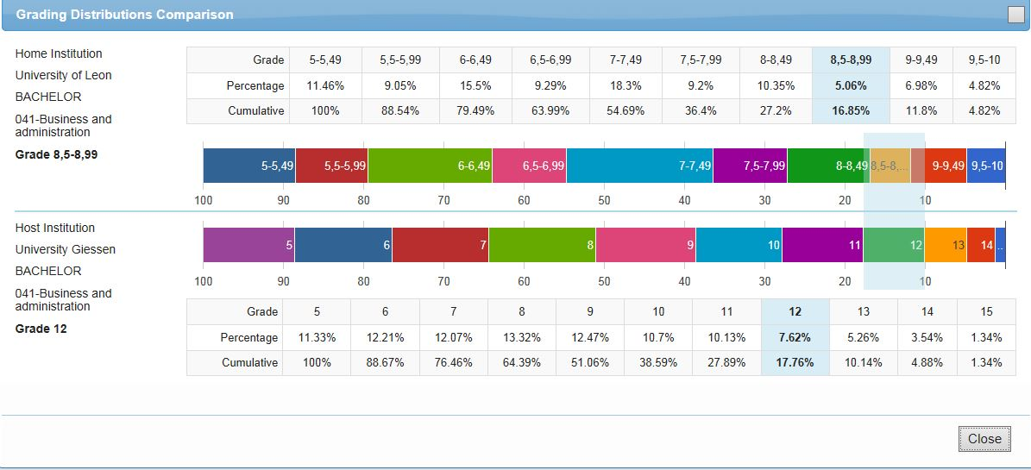

Graphic representation of grading tables
Grading tables can be represented as frequency tables (see above) but also graphically. When doing so, institutions are invited to represent the grades on the horizontal axis and the percentages on the vertical axis. The following is an example. The graph does not show the accumulated frequency.

Another visual representation (probably clearer) is the following:

* = Accumulated frequency

A third representation that may be more suited to the ToR is to condense the grading table to 3 percentages:

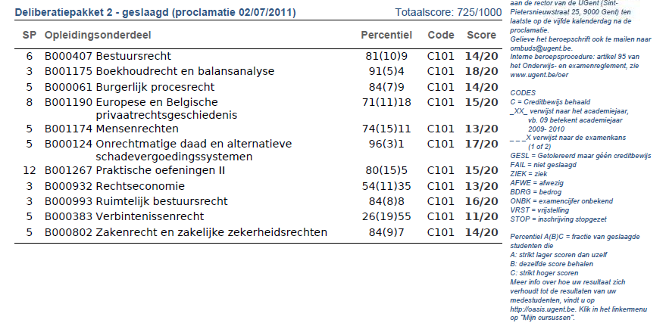
Here the mark of the student (e.g. 14/20) is related to those that have a higher mark (9%), those that have the same mark (10%) and those that have a lower mark (81%). In this example it is clear that with 14/20 the students belongs to the top 19% of his cohort (9% + 10%)

Final Remarks

The main aim of the Egracons project is to develop an online, web based Egracons tool that will allow direct and automatic conversions of exchange student grades on the basis of annual, statistically-based grading tables supplied by individual institutions as part of an overall database.
But it also aims to build up a wide-spread awareness and common understanding of the different grading systems in Europe and to enable an accurate interpretation of grades (or marks) given abroad. Based on an extensive questionnaire we have elaborated country reports with a description of the grading systems in use in Europe. These country reports describe grading practices in all European countries with HEIs that take part in Erasmus mobility, and probably beyond that area at a later stage. HEIs will take part on a voluntary basis. Detailed explanations of distinctive features and grading cultures per country and institution are provided, including the range of grades, condoning, the average distribution of grades, required overall averages or not, specific bands within grades, differences among disciplines, etc. This allows for a better interpretation of each grading system and hence of the grades suggested by the online tool. For some countries a first draft is already available. We invite everyone to help us fine tune the info by sending us your comments.

http://www.uis.unesco.org/Education/Pages/international-standard-classification-of-education.aspx

